PROJECT:3

**Run a Serverless Webapplication**

In this project we will make a serverless webapplication in which we are using Lambda function for hosting the server less web application which is access by a IAM role and the data of the serverless application can be stored inside the S3 bucket and the host is able to acces the user data stored inside it.

**STEP 1: CREATE A IAM ROLE FOR ACCESS:-**

**First create a IAM role select type as AWS services,then select the service as Lambda and click on the next permission.**

**Then filter the policy as Amazon S3 full access,and Amazon cloud watch full access.**

**Then Review it and give it a name in the space of role_name as Lambda_S3_access then hit on the create role.**

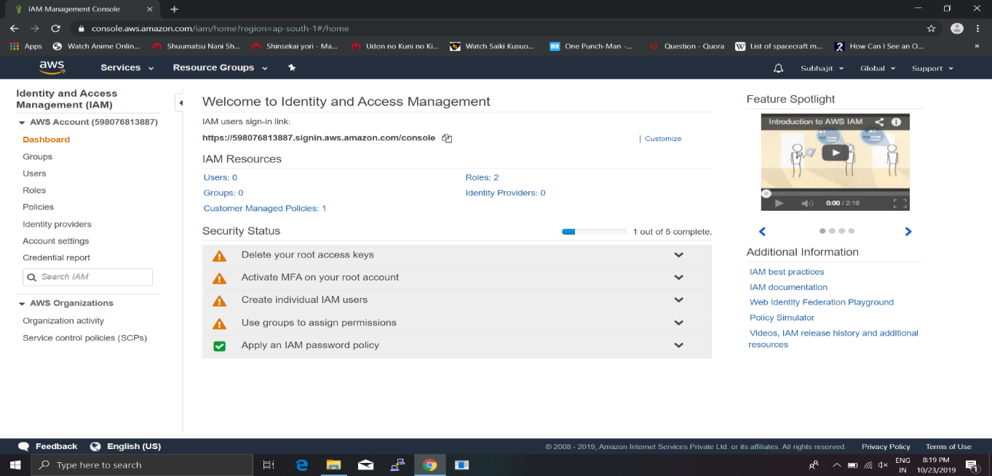

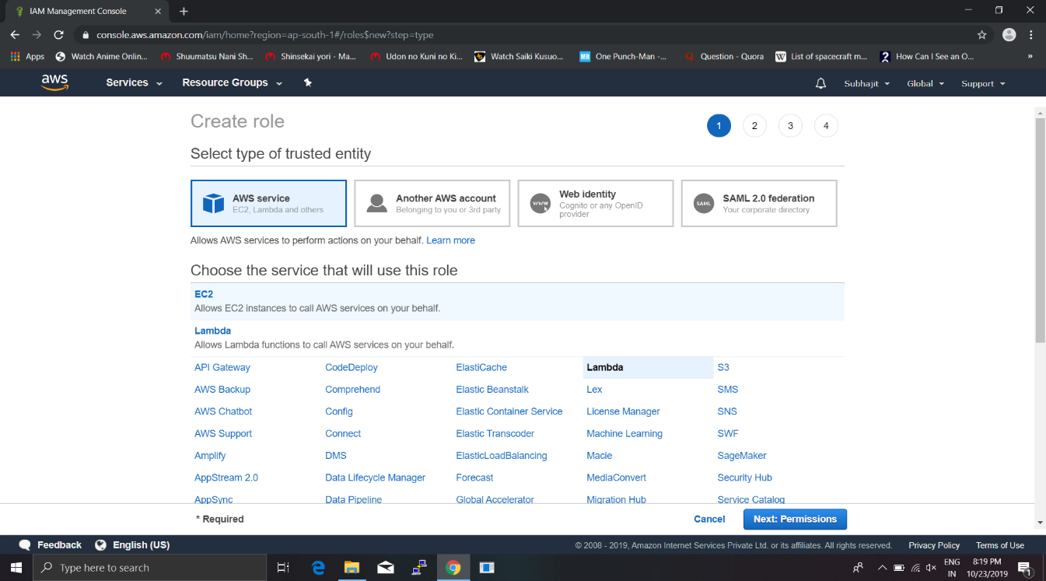

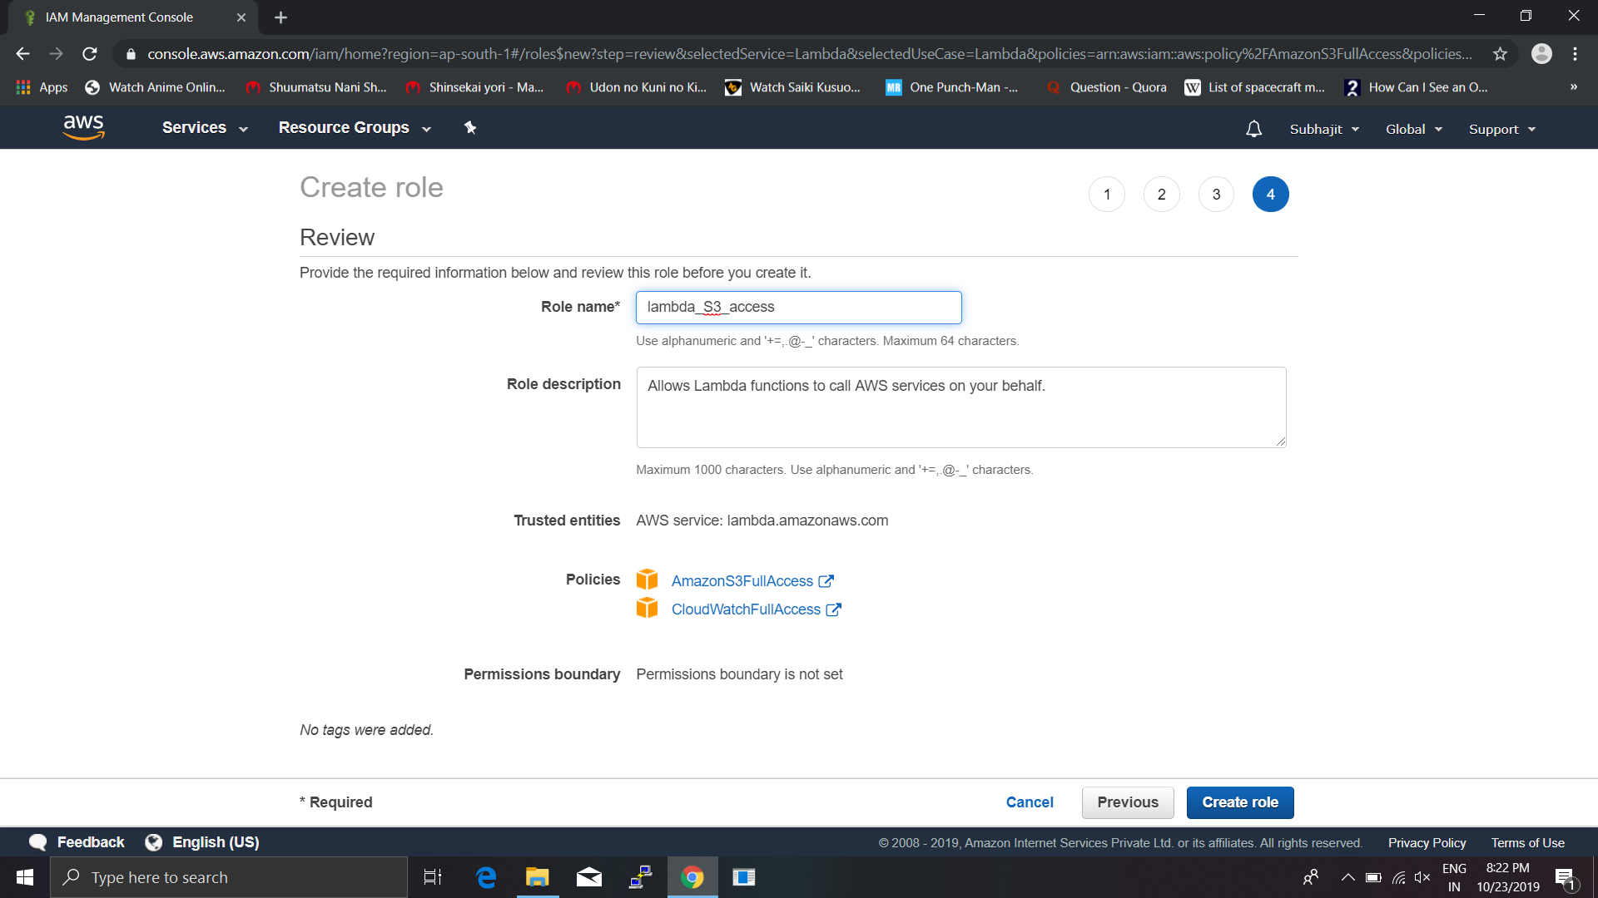

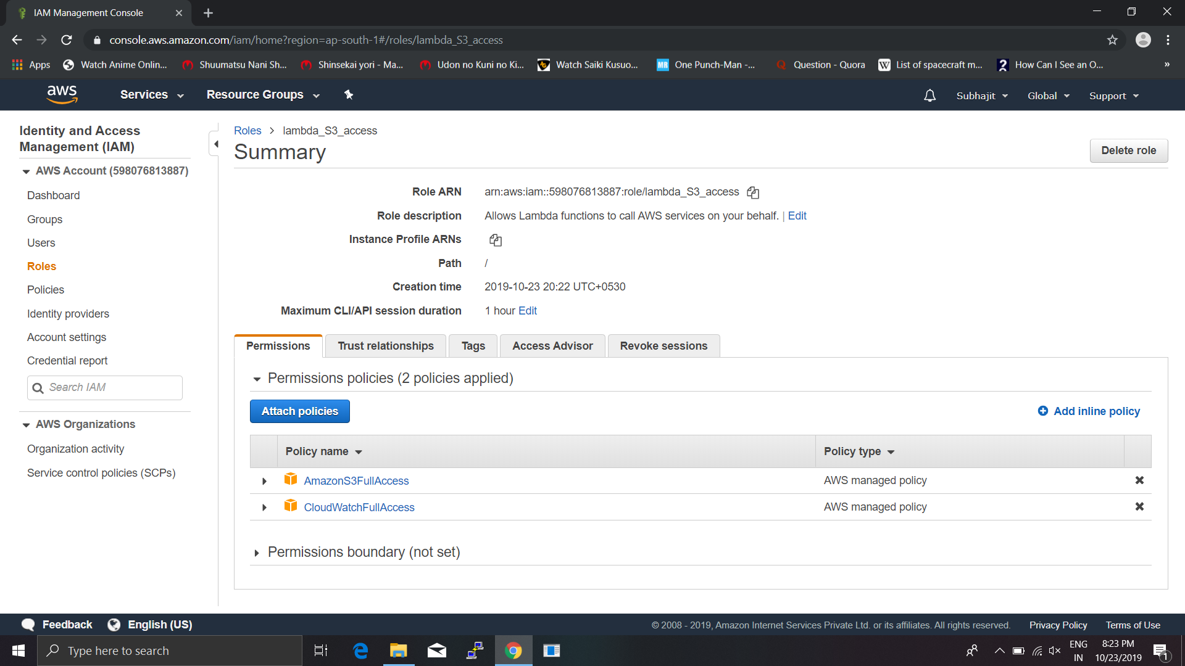

**STEP 2:CREATE A S3 BUCKET:-**

**First choose the S3 services from console then create a bucket named it anything then choose it give public access.**

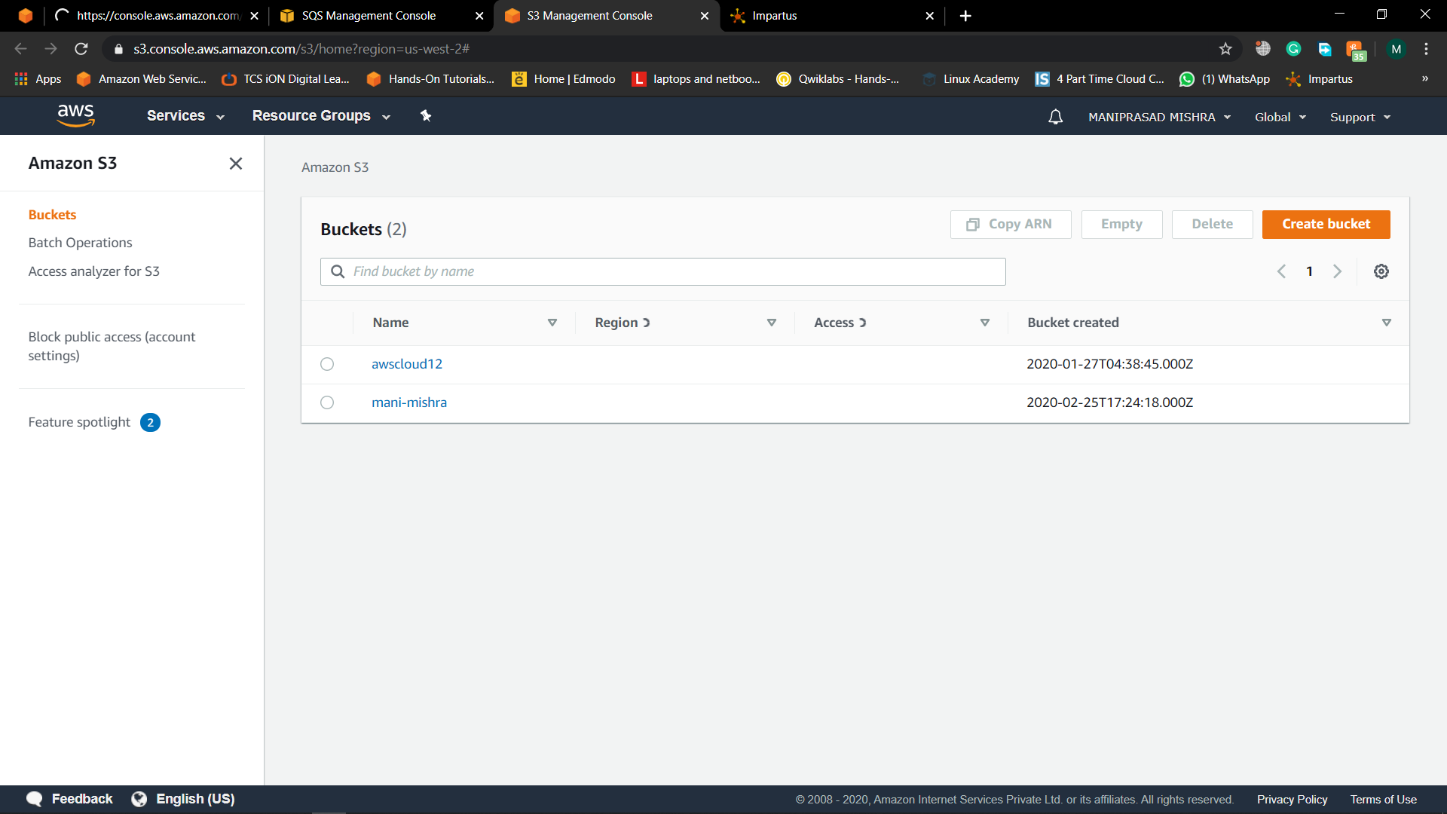

**STEP 3: CREATE A LAMBDA FUNCTION:-**

**First click on Lambda from the services then create a function**

**Choose author from scratch configure it function name as s3-trigger runtime environment is Python 3.7 in the IAM role space choose the existing role Lambda_S3_access then click on create function.**

**Then choose Add trigger then it goes to triger configuration page then search S3 then choose the bucket name in event type choose all events, then add it to the lambda function.**

**Then edit the python code created inside the lambda function**

**And create the function save it and run it.**

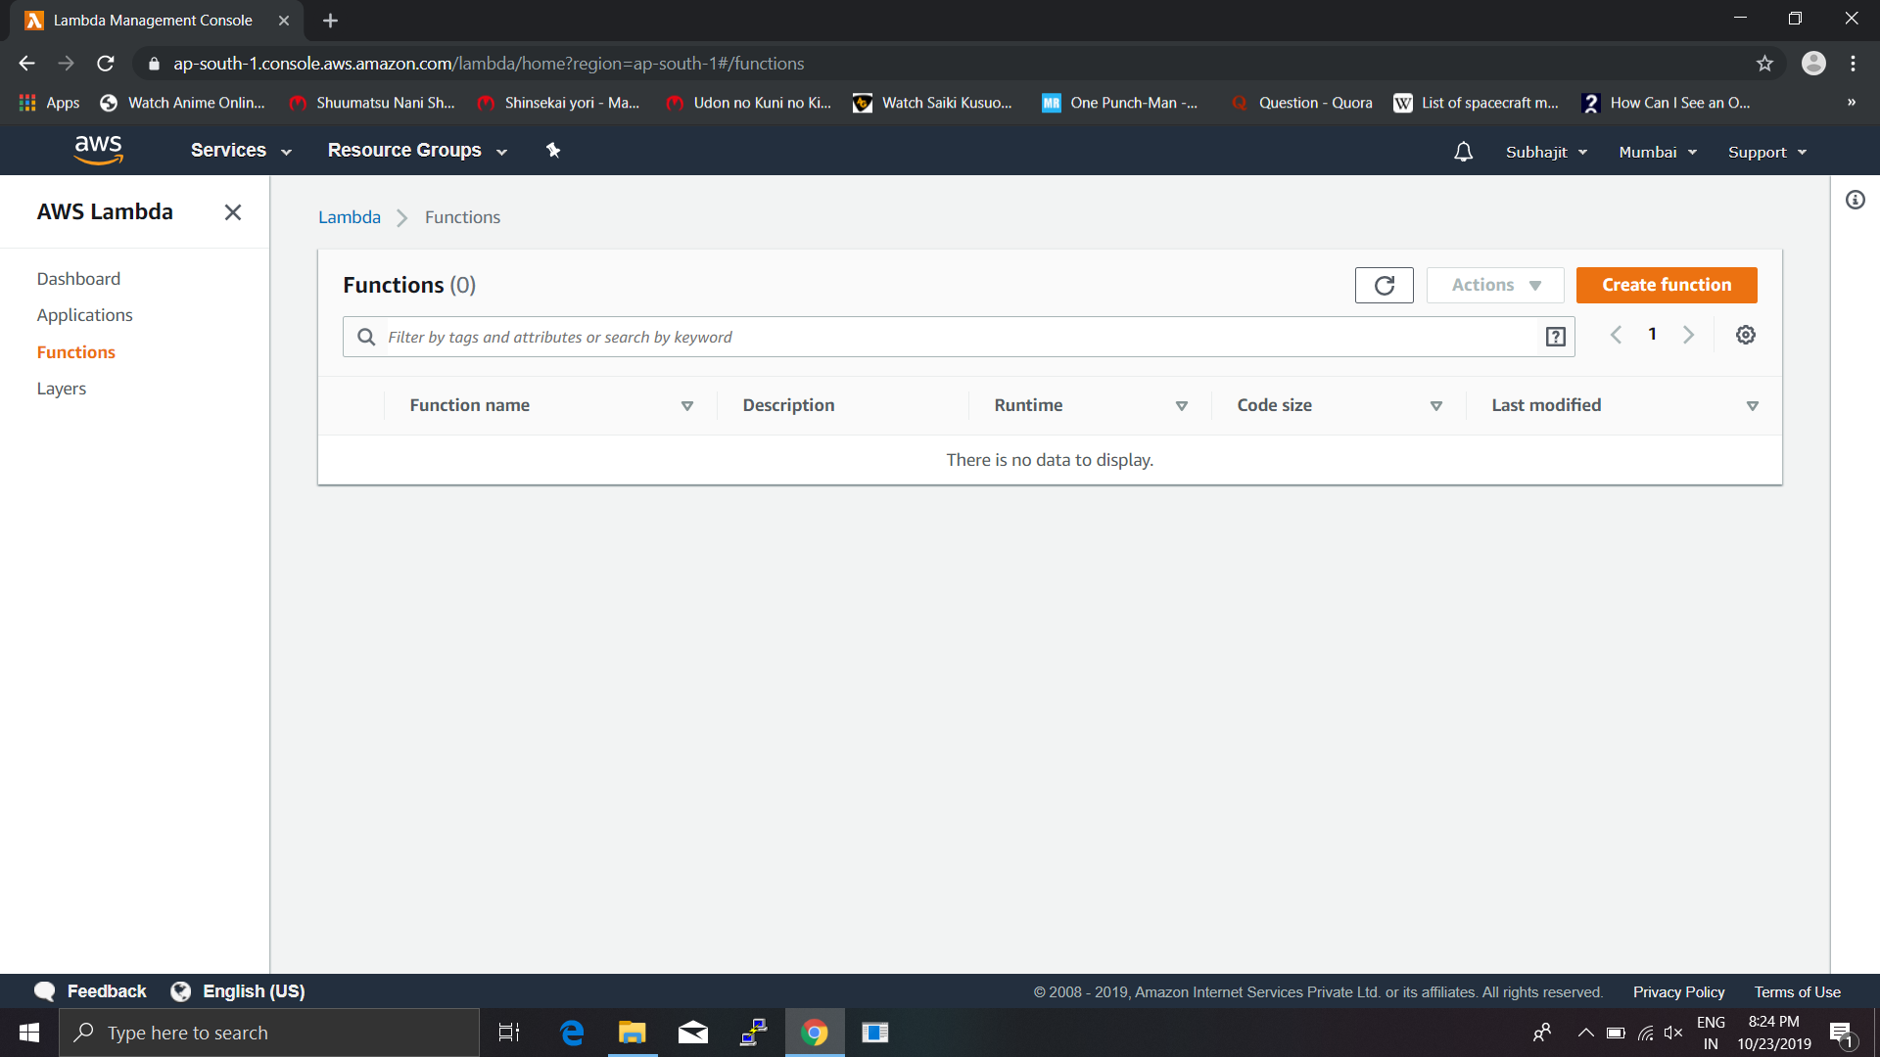

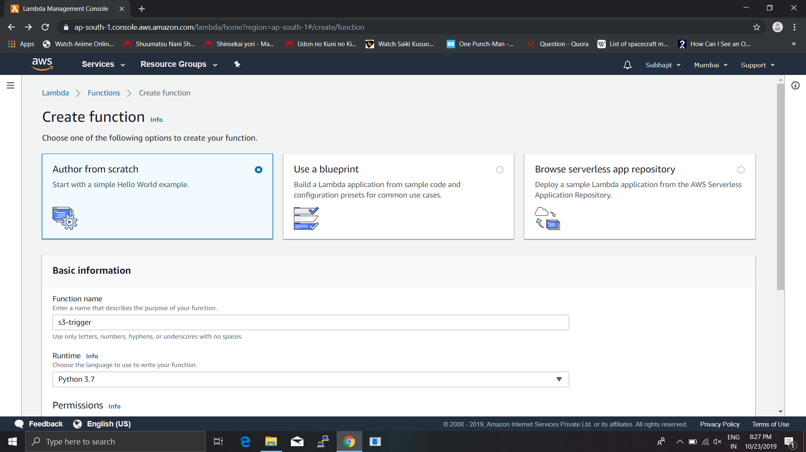

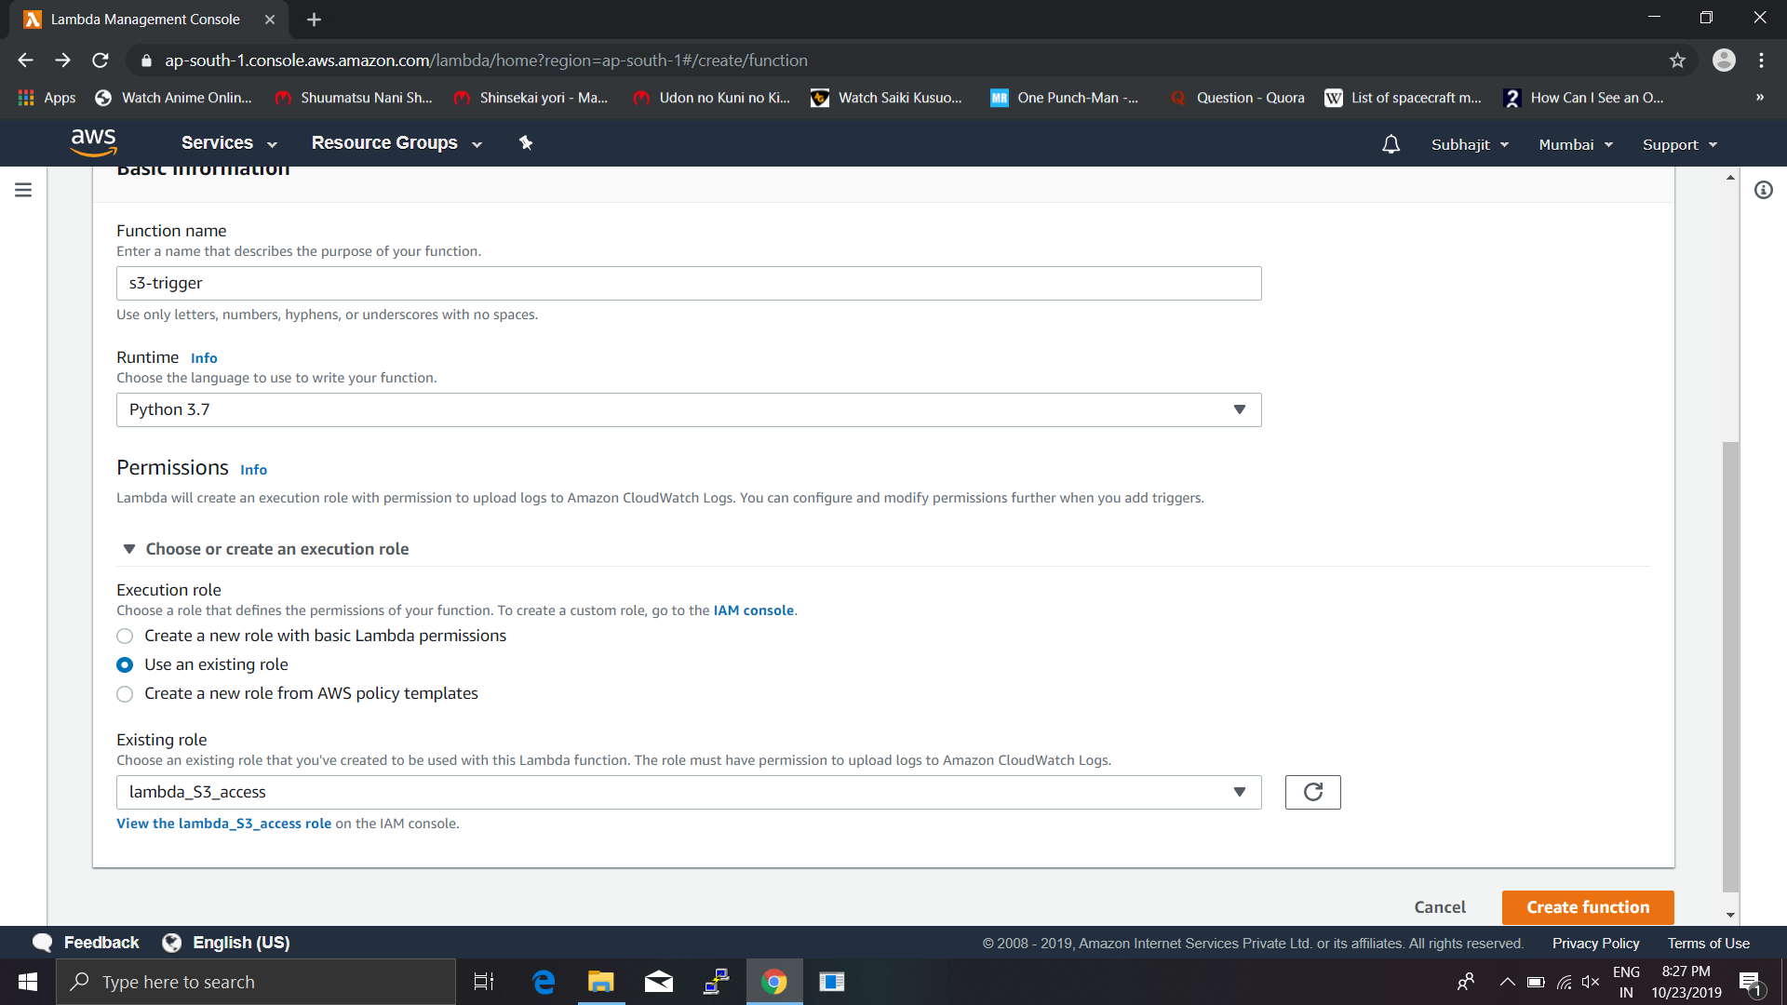

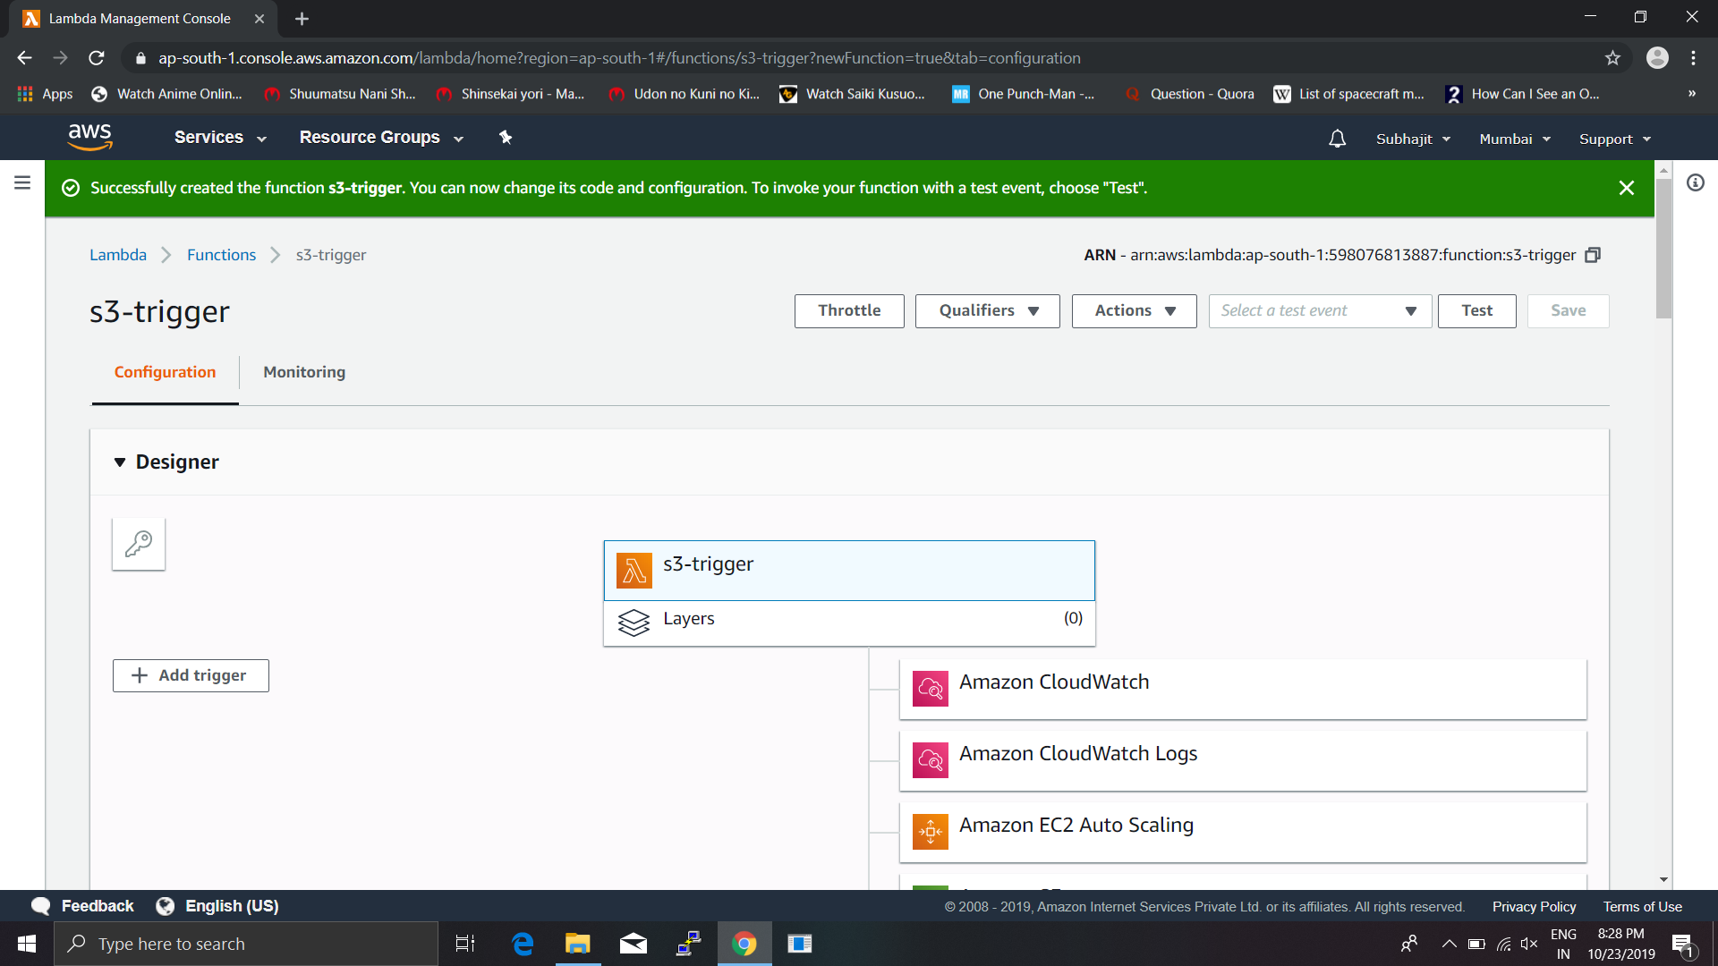

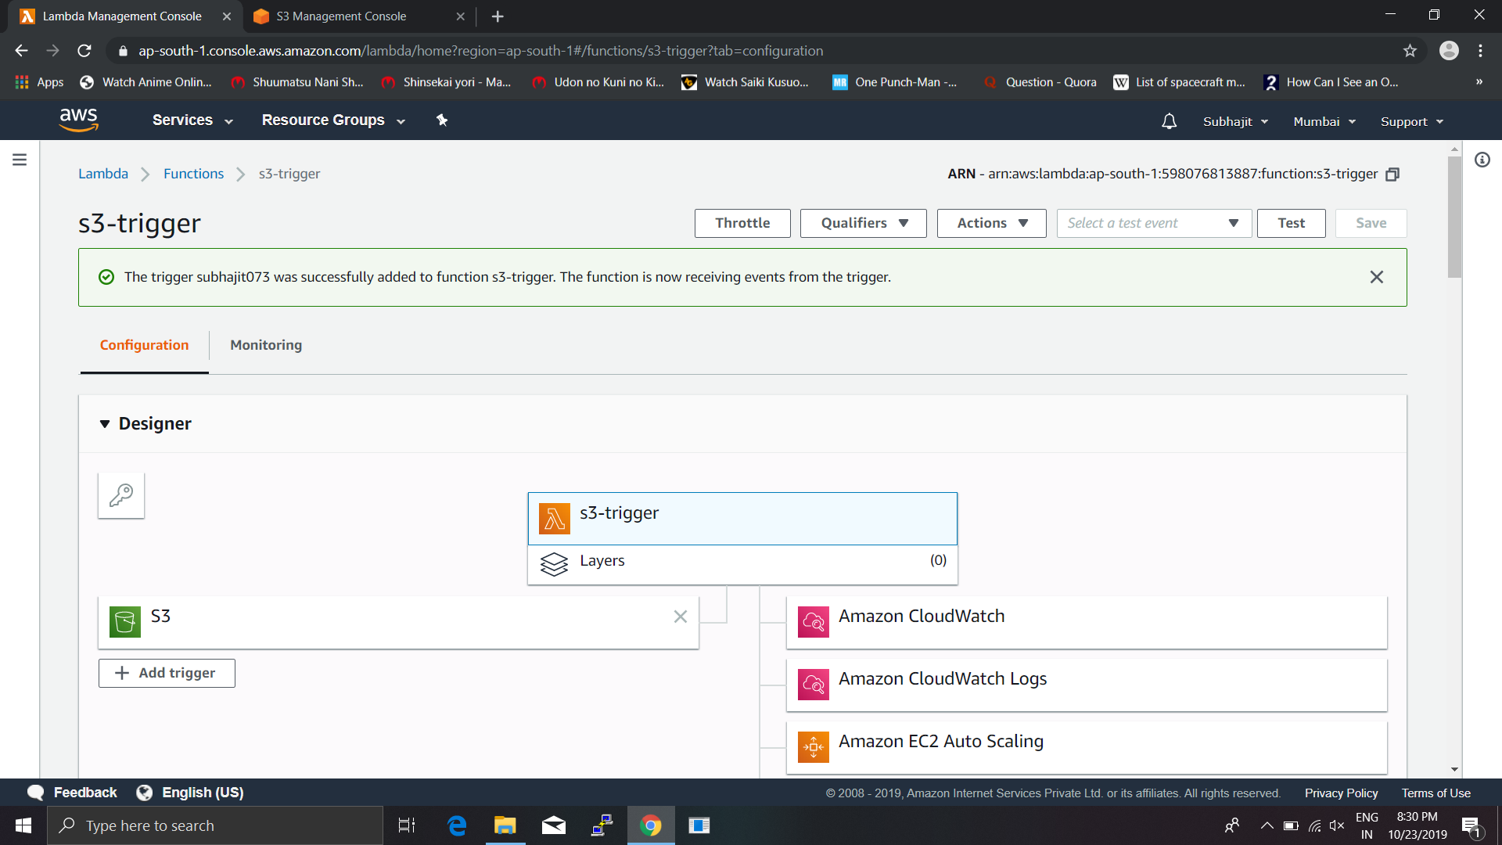

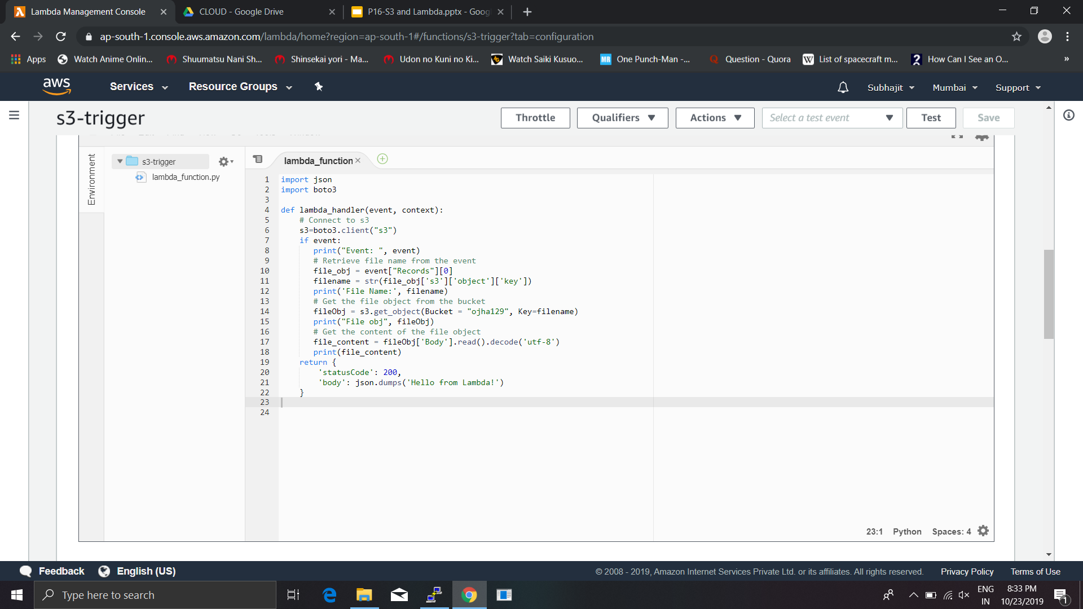

**STEP 4:DELETE ALL THE SERVICES:-**

**Delete all the services like Lambda function and IAM role for restricting Billing issue.**

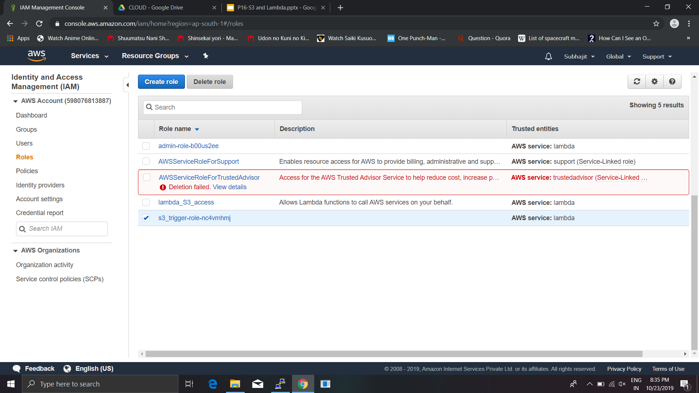

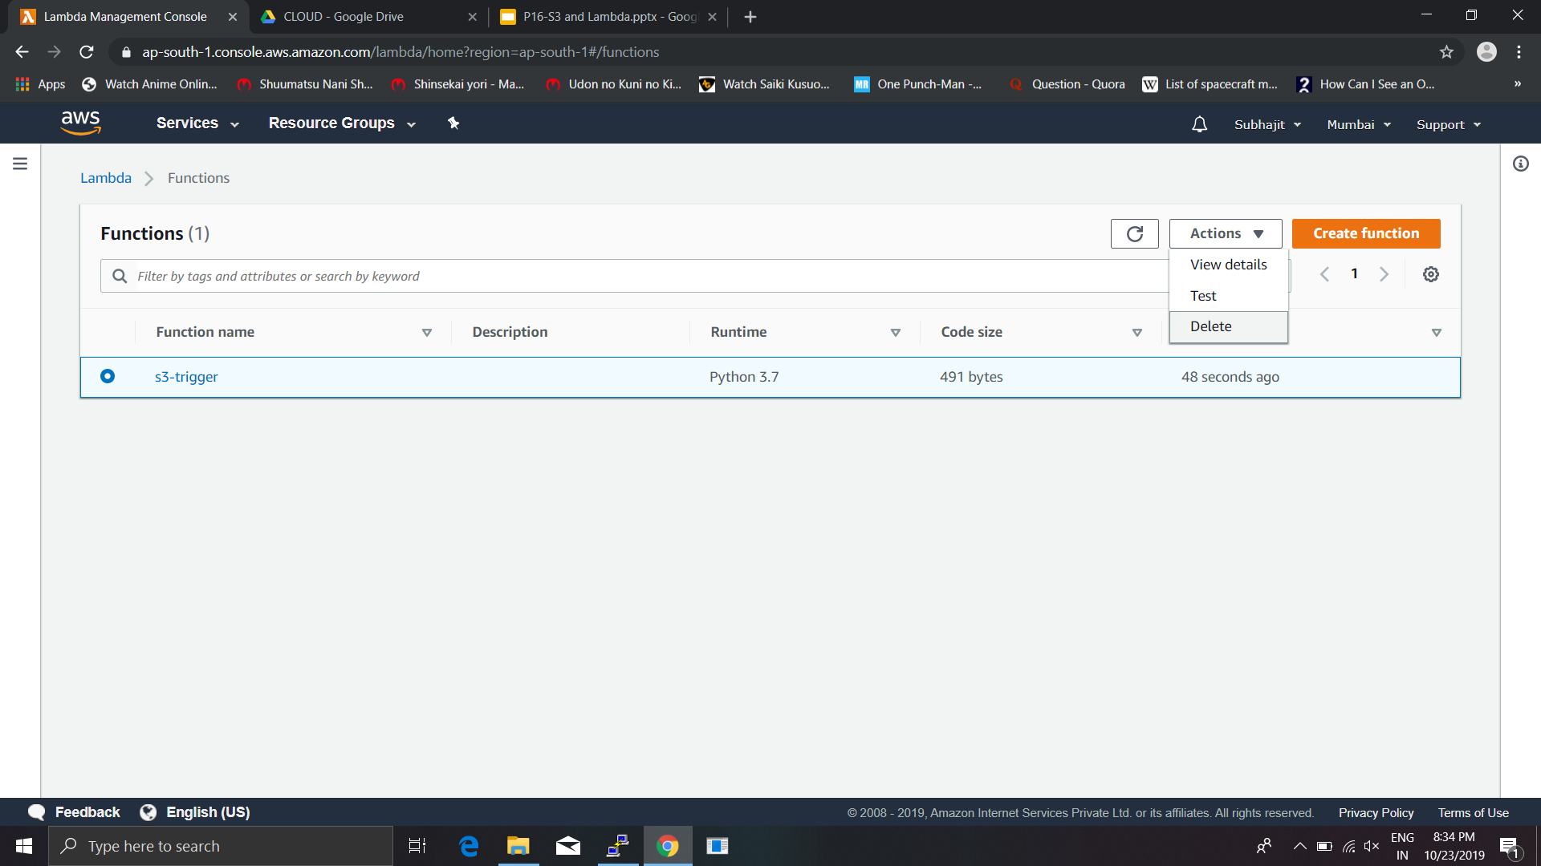

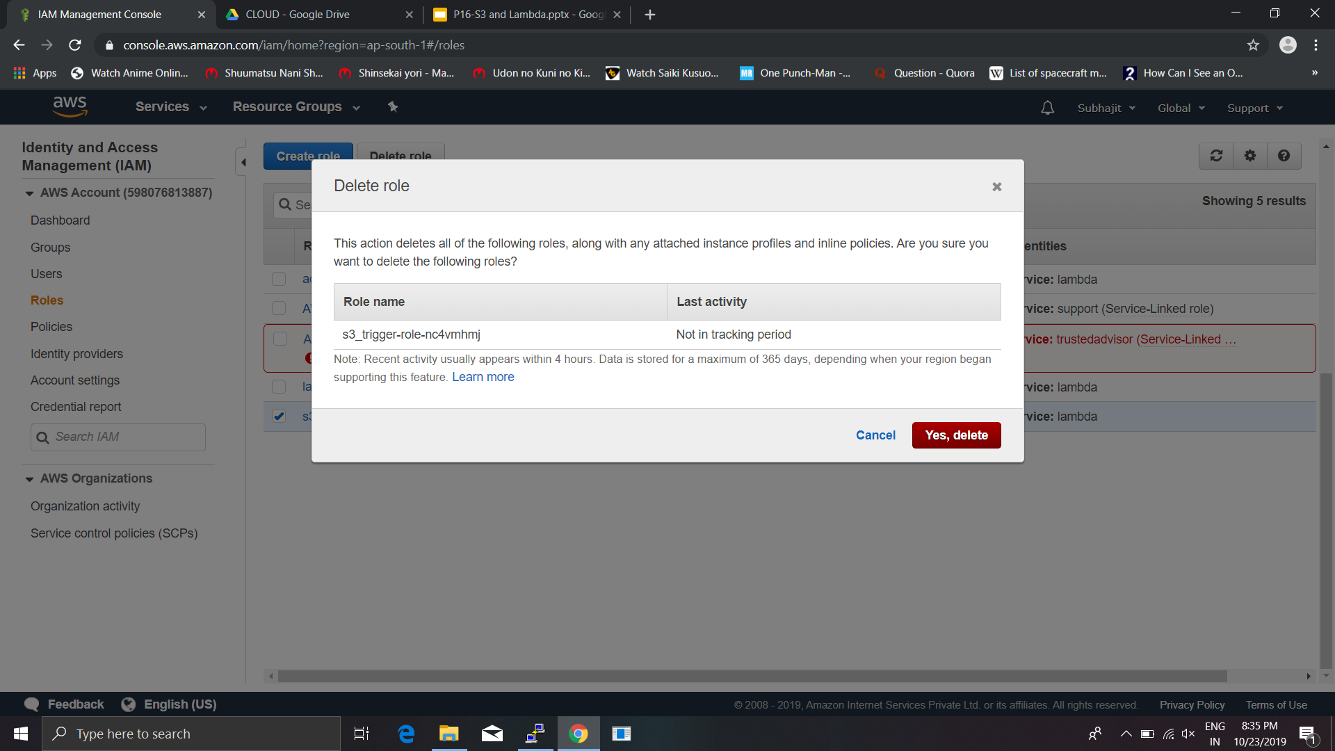

****************END****************